join us for our SECOND ANNUAL
MID-MISSOURI FINE ARTS SOCIETY
Plein Air Event
Saturday, September 28 (7:00 a.m. - 6:00 p.m.)
and Sunday, September 29 (7:00 a.m. - 2 p.m.), 2013
in scenic downtown Washington, Missouri

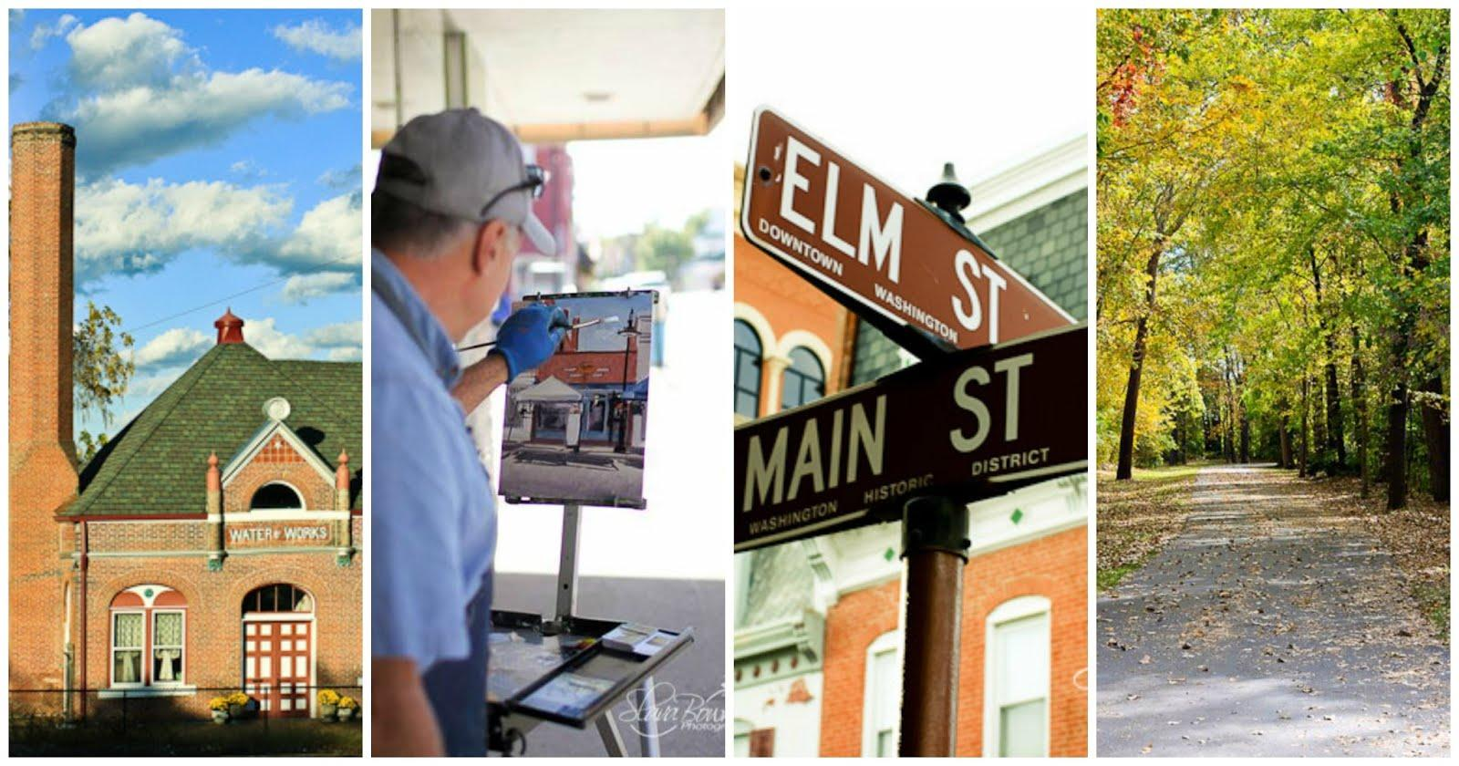
With its scenic riverfront, museums and galleries, and more than 445 buildings on the National Register of Historic Places, Washington is a gem along the Missouri river. Bring your paints and brushes and experience the Heart of the Wine County!

· $20 entry fee by September 1st; $25 entry fee after September 1st
· Check-in: 7-11am on Saturday and Sunday at the MMFAS booth at the Fall Festival of the Arts and Crafts on Main Street
· Judging begins at 3pm on Sunday, September 29th at the Art Center Gallery.
· Reception at 4 p.m. on Sunday at the Art Center Gallery,120 W. Main Street.
· Cash prizes and gift certificates to local businesses will be awarded.

For more information call Marty Coulter, 314-412-4599 or e-mail: slavabowman@yahoo.com.
Go to Facebook for details and an entry form: https://www.facebook.com/MidMissouriFineArtsSociety
Send entries to MMFAS, P.O. Box 2043, Washington, MO 63090.

